**Assignment VI (MA226)**

**Name: Sourav Bikash**

**Roll No.:11012338**

**Submission Date: 08/03/2013 Time:23:59 hrs.**

**Aim of the Problem:**

The problem involves the generation of discreet distributions namely geometric, Poisson and Weibull distributions.

**Mathematical Analysis/Theory:**

**Generating from geometric distribution:**

It can be shown that with a random number U, then

**X=Int( log(U)/log(q) ) + 1.**

is indeed geometric with parameter p.

Thus using U we can generate X following geometric distribution.

**Generating from Poisson distribution:**

For the case of the Poisson, we exploit the recursion property

pi+1 = (λ/(i+1))pi for i > 0.

The following steps can then be followed to generate from a

Poisson with parameter λ:

step 1: generate a random number U.

step 2: set i = 0 , p = e-λ and F = p.

step 3: if U < F , set X = i and STOP.

step 4: set p = λp/(i+1), F = F + p , and i = i + 1.

step 5: return to step 3.

**The composition of two distributions:**

Consider now simulating from a distribution with mass function

**P(X = j) = αpj(1) + (1-α)pj(2) ; j >0; 0 < α < 1**

If X1 and X2 are the random variables with respective mass functions , then **pj(2)** and **pj(1)**

**X = X1 with probability α**

**X2 with probability 1 -α**

One approach then to generate from this mixture distribution is :

step 1: generate a random number U1

step 2: generate from X1 and X2 distributions.

step 3: if U < α; set X = X1.

step 4: else if U >α , set X = X2;

**Part I:**

This question wants us to generate 50 random numbers following geometric distribution. For this we take p=0.4.

**Implementation using R:**

geomdist<-function(n)

{

RN<-NULL;

for(i in 1:n)

{

u1<-runif(1,min=0,max=1);

p<-0.4;#taking p=0.4

q<-1-p;

x<-floor(log(u1)/log(0.4))+1;

RN<-c(RN,x);

}

return(RN);

}

s<-geomdist(50);

mass <- NULL;

for(i in 0:max(s))

{

m <- sum(as.integer(i == s));

mass <- c(mass,m);

}

mass <- mass/50;

x <- seq(0,max(s));

**Using the output the following mass function generated:**

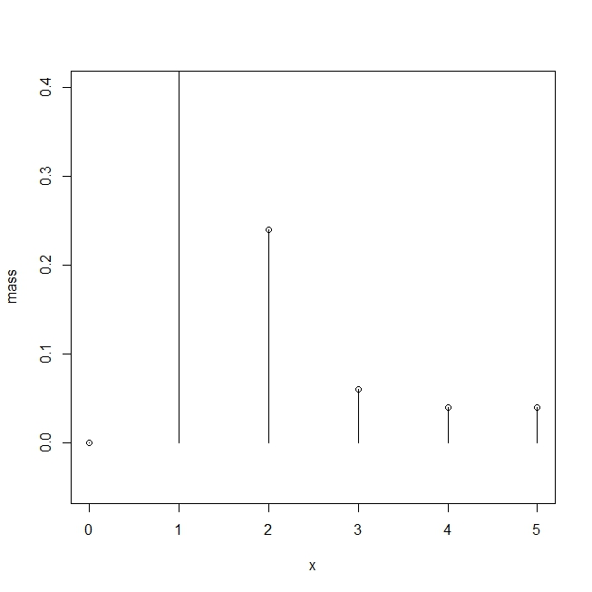

**Part II:**

Here we need to generate 50 random numbers following poisson distribution.

**Implementation using R:**

poisson<-function(n)

{

RN<-NULL;

for(i in 1:n)

{

u1<-runif(1,min=0,max=1);

i<-0;

p<-exp(-2);#mean=2

f<-p;

#x<-i;

while(u1>f)

{

p<-p*2/(1+i);

f<-f+p;

i<-i+1;

}

x<-i;

RN<-c(RN,x);

}

return (RN);

}

s<-poisson(50);

mass <- NULL;

for(i in 0:max(s))

{

m <- sum(as.integer(i == s));

mass <- c(mass,m);

}

mass <- mass/50;

x <- seq(0,max(s));

**Using the output the following mass function was generated:**

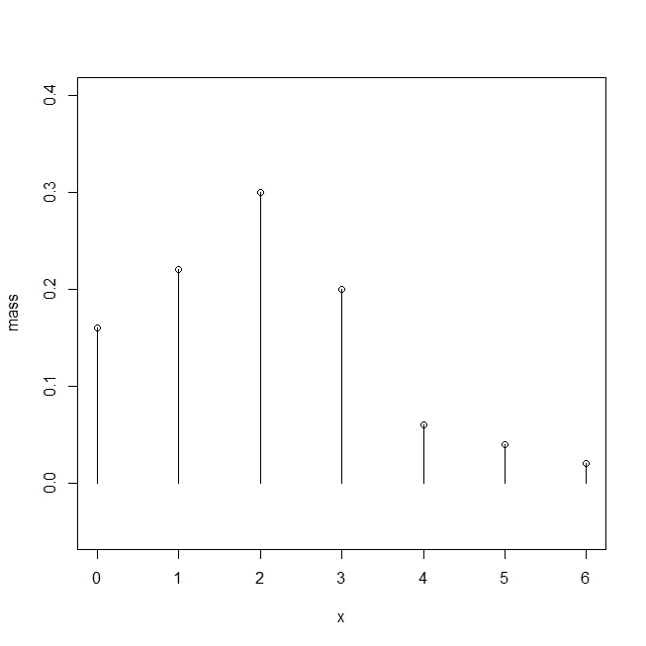

**The cumulative distribution of the numbers was like this:**

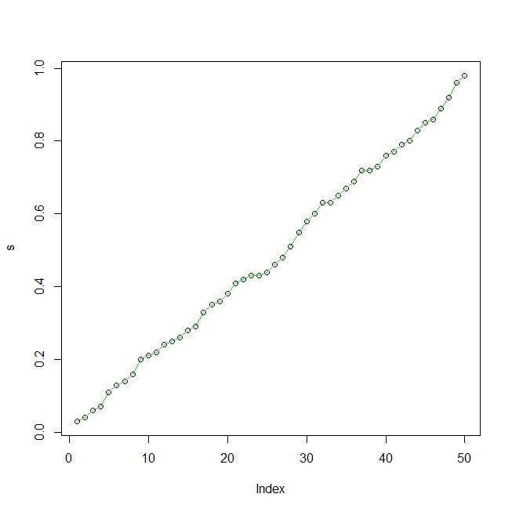

**Part III:**

This question asks us to generate joint-Weibull distribution.

**The R code:**

weibull<-function(n){

RN<-NULL;

for(i in 1:n)

{

u<-runif(1,min=0,max=1);

x1<-sqrt(log(1/u));

x2<-(sqrt(log(1/u)))^3;

if(u<=0.4)

{

x<-x1;

RN<-c(RN,x);

}

if(u>0.6)

{

x<-x2;

RN<-c(RN,x);

}

}

return(RN);

}

s<-weibull(50);

**The output was used to generate a histogram:**

